# **SuperStore Power BI Report**

**1.Profit by Region**

**Visualization:**

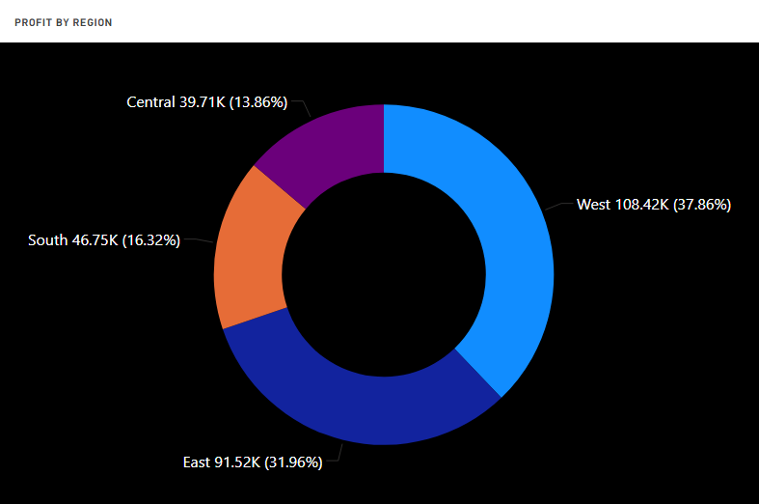

**Explanation:** This explains the profit by region by using donut chart.

**2.Profit by Segment**

**Visualization:**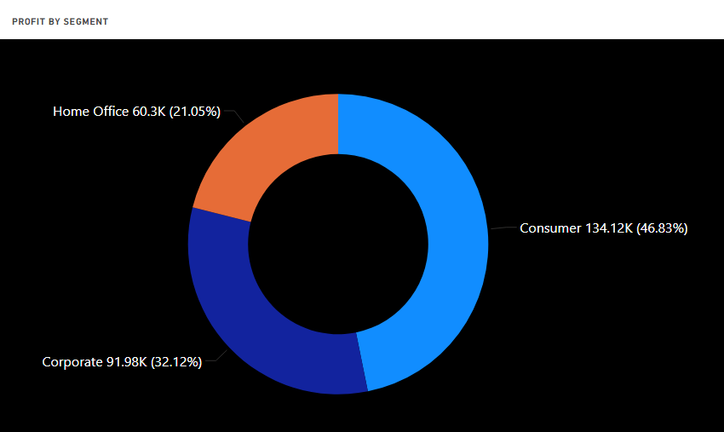

**Explanation:** This explains the profit by segment by using donut chart.

**3.Profit by Category**

**Visualization:**

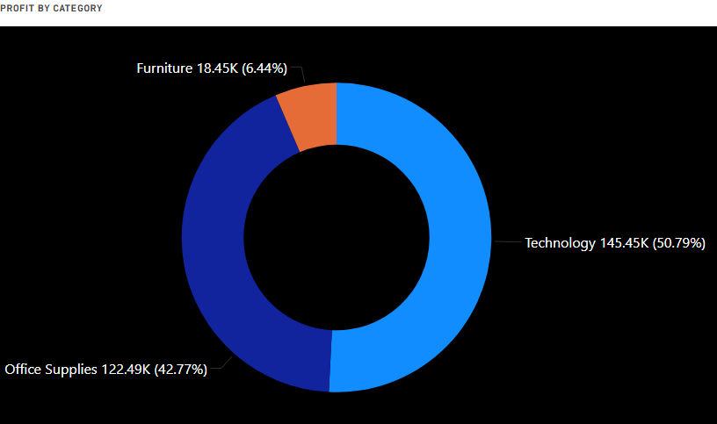

**Explanation:** This explains the profit by Category by using donut chart.

**4.Profit by Sub-Category**

**Visualization**

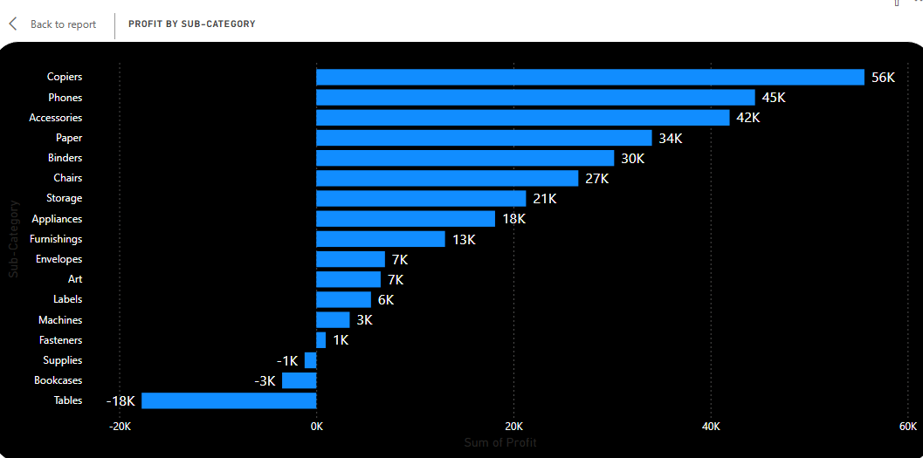

**Explanation:** This explains the profit by sub-category by using stacked bar chart.

**5.Profit by Year and Quarter**

**Visualization**

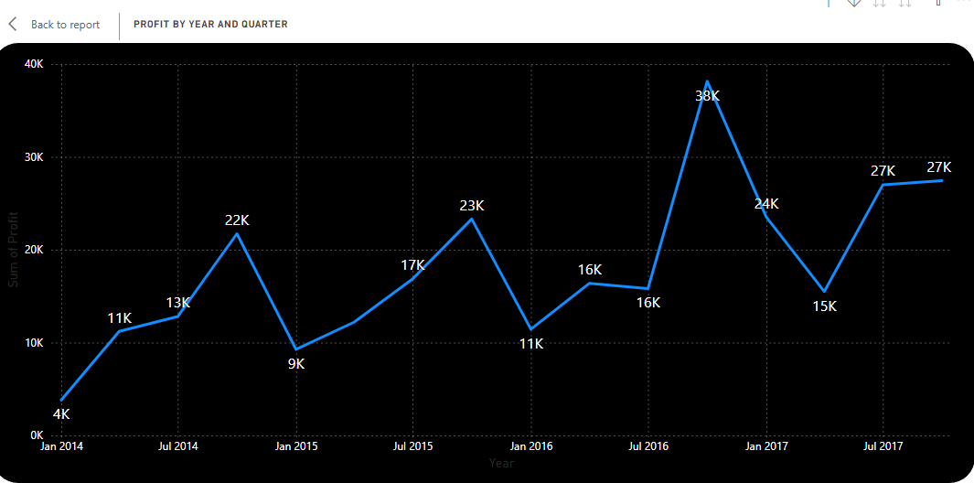

**Explanation:** This explains the profit by order date by using line chart.

**6.Sub-Category, Region and Sales**

**Visualization**

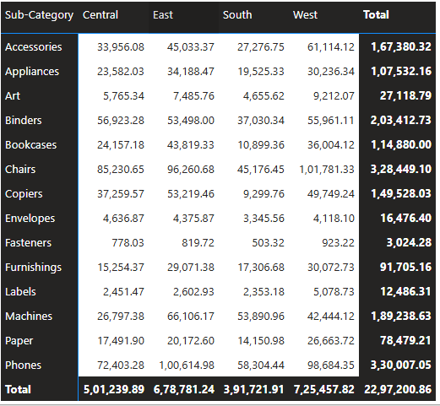

**Explanation:** This explains the sub-category, region and sales by using a simple matrix.